Sink/Cabinets

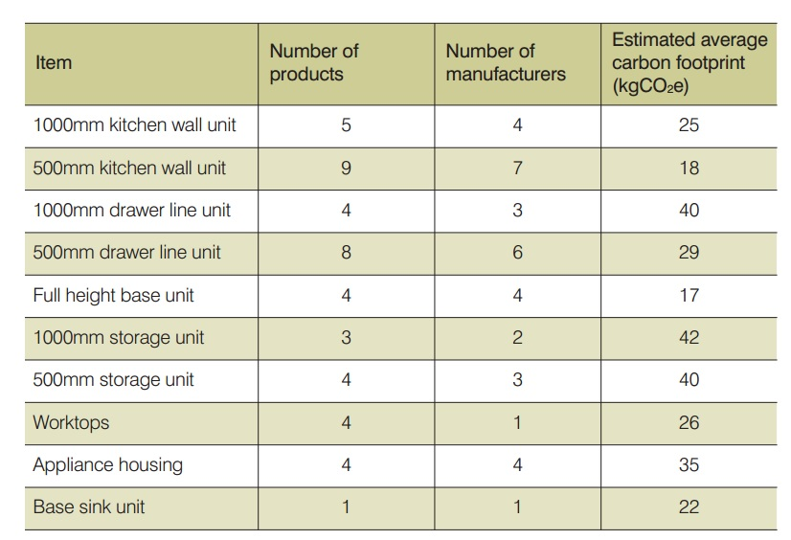

Cabinets:

-1000mm kitchen wall unit. A wall hanging carcass unit 1000mm in width with a set of double doors and at least one shelf.

• 500mm wall unit. Similar in carcass construction to the 1000mm wall unit but half the width. Due to its smaller size it also only has a single door.

• 1000mm drawer line unit. A base unit normally featuring a cutlery drawer, a door and at least one shelf.

• 500mm drawer line unit. Similar in carcass construction to the 1000mm drawer line unit but half the width. Due to its smaller size it also only has a single door

Source:

<https://www.fira.co.uk/document/fira-carbon-footprinting-document-2011.pdf>

ACTUAL CALCULATIONS

Rather than look at the amount of wood used in the surface area of a cabinet, and disregard the hardware and shelving, it was decided to scale the values provided above according to cabinet space itself. It was thus assumed that there was direct, and proportional relationship between cabinet volume and embodied carbon.

|  |  |  |  |  |  |  |  |  |
| --- | --- | --- | --- | --- | --- | --- | --- | --- |
|  | 500mm Base Unit Dimensions | Volume  (in^3) | kg CO2/  500mm unit | **kg CO2/ in^3** | 1000mm Base Unit  Dimensions | **Volume**  **(in^3)** | kg CO2/  1000mm unit | **kg CO2/ in^3** |
| Drawer Line Unit | 50 cm x 72 cm x 56 cm | 12,302 | 29 | 0.002357 | 100 cm x 72 cm x 56 cm | 24,605 | 40 | 0.001626 |
| Cabinet (Kitchen Wall Unit) | 50 cm x 72 cm x 30 cm | 6,591 | 18 | 0.00316 | [100 cm x 72 cm x 29 cm](http://www.diy.com/departments/it-kitchens-white-standard-wall-cabinet-h720mm-w1000mm-d290mm/37272_BQ.prd) | 12,742 | 25 | 0.001962 |
| Storage | 50 cm x 72 cm x 56 cm | 12,302 | 40 | 0.00325 | 100 cm x 72 cm x 56 cm | 24,605 | 42 | 0.001707 |

VERY IMPORTANT:See how the kg CO2/in^3 is larger for the smaller volume? This is because there is a higher amount of open space in the larger cabinet and a smaller ratio of actual wood per volume AND the hardware doesn’t change much from larger to smaller.

Thus, **it was assumed** that due to the space constraints of the tiny house t**hat the 500mm values would be closer to the true values.**